Japan
Friday, February 28, 2025 to Friday, March 14, 2025

Tokyo, Japan
Saturday, March 1st – Tuesday, March 4th

Hi / Hello: こんにちは Kon'nichiwa
Thank you: ありがとうArigatō
Please: お願いしますOnegaishimasu
Excuse Me: すみませんSumimasen
Gluten Free: グルテンフリー Gurutenfurī
Wheat: 小麦 Komugi
Rye: ライ麦 Raimugi
Barley: 大麦 Ōmugi
Oats: オーツ麦 Ōtsu mugi
Celiac: セリアック病 Seriakku-byō

155 Yen = $1 / $100 = 15,567 Yen / 10,000 Yen = $65 / 100,000 Yen = $642

General Tokyo Info:
- Still have to pay cash in a lot of places
- Public transport – Suica card for everything except for Shinkansen/bullet trains
- Tap water is safe to drink but might taste a bit like chlorine. You can boil it in the kettles at the hotel to get rid of the taste.
- Tipping does not seem to be a thing (and is sometimes considered rude) unless you’re at a very upscale ryokan or in other situations.

Friday, February 28th
AA Flight 448 to LAX from DFW at 8:05am
- Arrive at LAX at 9:35am

JAL Flight 15 to HND from LAX at 12:30pm
- Arrive at HND at 5:30pm the next day March 1st

Saturday, March 1st Tokyo
Head to Hotel (Tokyu Stay Aoyama Premier) to Check-In
- Directions from Airport: Take the blue Keikyu Airport Line Limited Express Imbanihon-Idai 8 min (5 stops) to the Keikyu Imbanihon-Idai Main Line (stay in same vehicle) 12 min (4 stops) to red Asakusa Line Imbanihn-Idai (all while staying in same vehicle) 3 min (3 stops) to Shimbashi Station
  - Once at Shimbashi Station, take the orange Ginza Line Local Shibuya 9 min (5 stops) from Platform 1 to Gaiemmae Station
  - From Gaimmae Station walk about 5 min, 350m to hotel
  - KD Notes: nice hotel and very worth it having the washer/dryer in room. But seemed a little out of the way except for Shibuya? – would probably try to stay closer to Ginza next time.
  - KD Notes: Public transport is veryyy easy to figure out. Download the Suica card to your apple wallet and just tap to pay.
- During check-in, see if I can ship luggage to Hakone
  - KD Notes: Did this and it was awesome! It was only like $14 to send my carry-on to the hotel in Hakone. I dropped it off by 10am the day before checkout, and it was at the hotel in Hakone when I checked in the next day. But keep in mind you’re without a bag for 24-48 hrs so you need to plan accordingly. pack a dayback.

Dinner Options Near Hotel:
- Esoragoto Udon: only open until 8:30pm; GF udon noodle stall; 13 min walk from hotel
  - KD Notes: Didn’t go
- Gluten Free T’s Kitchen: open until 10pm
  - KD Notes: Went for dinner another night and it was pretty good! Had a GF Japanese beer and veggie ramen.
- Otsuna Sushi: open until 10pm
  - KD Notes: Didn’t go
- BREIZH Café Crêperie Omotesando: open until 10pm; GF buckwheat crepes
  - KD Notes: This was so good! Went for lunch on the last day. Was scared they were rude bc of reviews, but they were SO nice and spoke excellent English (as well as Japanese and French)

Sunday, March 2nd Tokyo
Lunch at Kushiage Su (Ginza) at 12pm
- 5 course omakase skewer lunch at 12pm (have res)
- Seems kind of hard to find:
  - Ginza Park Building 2F, 8-15-2 Ginza, Chuo-ku
  - Https://maps.app.goo.gl/XFvZAJgx71ghFNpW6? G_st=in
  - For location details, please visit the Instagram (https://instagram.com/glutenfree_kushiage) Stories Highlight Access page.)
- KD Notes Afterwards: was SOOO good! Not really that hard to find. He didn’t end up understanding pescatarian in my reservation, so I had one wagyu beef skewer and one with bacon :/ Booking for dinner when I am back in Tokyo on 3/13.

Flagship Uniqlo Store

Buy HEATTECH Ultra Warm Leggings for Hakone and Kyoto bike tour

Open 11am-9pm every day

Walk around Harajuku, Shibuya and Shinjuku
- Hachiko statue (dog) near Shibuya Scramble
- Meiji Jingu Consecrated Sake Barrels
- Shibuya Scramble
- KD Notes Afterwards: Went to Shibuya Scramble at like 6am on Tues so it was not hectic at all.

Go to Gōtokuji Temple
- Lucky cat temple (like the one Shen gave me!)
- ~30+ min on train but only costs $2
- KD Notes Afterwards: Was cute and worth it! Not a long trip at all. Paid 100 yen to get a fortune

Dinner at SUSHI KORIN Nishiazabu at 7pm
- have a reservation – sushi omakase

Monday, March 3rd Tokyo
Drop off luggage to send to Hakone no later than 10am

Shibuya/Shinjuku Early AM then back to hotel to drop things off
- Hachiko statue (dog) near Shibuya Scramble
- Shibuya Scramble
- Natural Lawson! Tomoko said it has better options
  - Didn’t find too many GF things but didn’t look too hard

Sushi Making Class at 12pm
- nearby: fragrance (open everyday from 11am-7pm)
- KD Notes Afterwards: Fish quality was NOT good. But class was fun and instructors were very sweet.

Need to go to the JR Ticket Station to print Hakone > Kyoto ticket and buy Osaka > Tokyo ticket

Imperial Palace

Dinner at Gluten Free T’s Kitchen at 6:30pm
- have a reservation

Tuesday, March 4th Tokyo to Hakone
Travel to Hakone
- Go to Odawara Station
  - Grocery shop here – see Ashley’s notes about no grocery stores in Hakone
  - Buy Hakone Freepass if I haven’t already
    - Can use Hakone Free Pass for anything from Odawara forward
    - Get 3 day pass for 5,400 yen from Odawara
- Odawara to Hakone-Yamuto Station
  - The Odakyu Line runs between Odawara and Hakone Yumoto. The trains run about every 15 min and takes about 15 min between stations
  - Ashley said there is a cute street of shops and restaurants right outside Hakone-Yamuto Station
- Hakone-Yamuto Station to Gora Station
- Gora Station then bus to hotel
  - At Gora make sure to go to Nukafuku (see below)

Hakone, Japan
Tuesday, March 4th – Friday, March 7th

https://www.hakonenavi.jp/international/en/

CONTINUED Tuesday, March 4th Tokyo to Hakone
Go to Nukafuku (fully gluten free and vegan café/dessert stall)
- Directions: inside the tourist shop opposite Gora station
- Have GF and vegan sausage and packets to make GF noodles
- It’s CLOSED wed & thurs; open 11-4 other days
- KD Notes Afterwards: Got there at 2:50pm and it was CLOSED it was snowing really hard so I guess the closure was unexpected, but very sad – the GF green tea donut looked really good!

Wednesday, March 5th Hakone
Hakone Loop thing
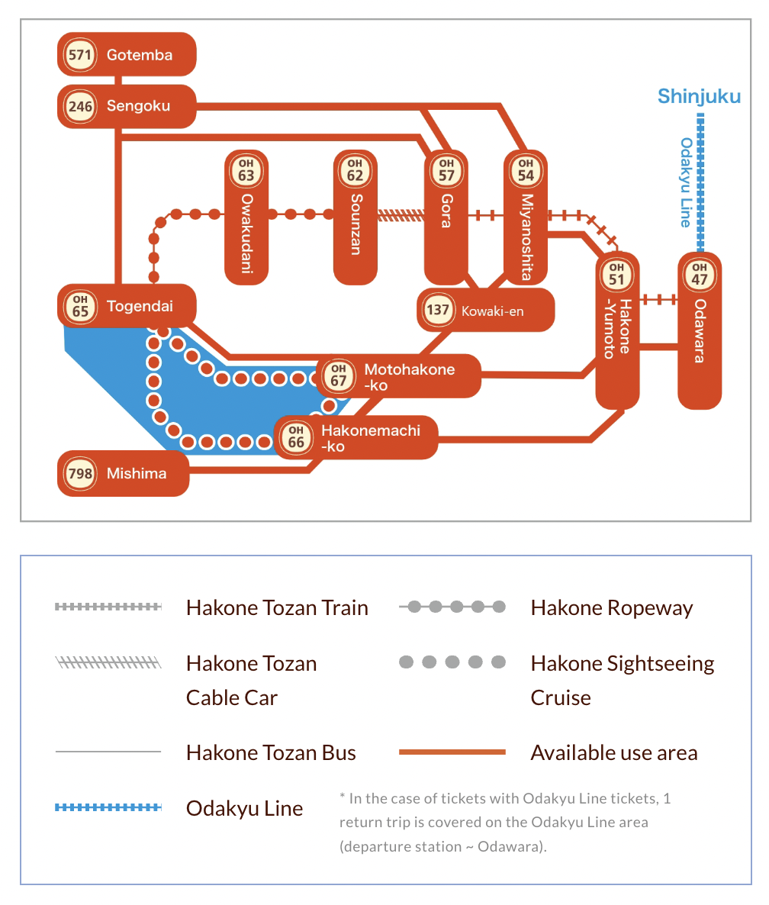

KD Notes: Going to have to do the loop tomorrow – too much snow on the ground today Just chilling in the room, catching up on work, reading books I brought, and planning more of the trip.

Thursday, March 6th Hakone
Workout in AM

Mount Fuji?? Seems really hard to get to
KD Notes: The weather was crap so not even going to try

Hakone Loop
KD Notes Afterwards: Loop was very cool but very crowded and took a lot longer than I expected.

Dinner at 5:30pm

Shiatsu Massage in room at 7:30pm

Friday, March 7th Hakone to Kyoto
Breakfast at 8:30am

Taxi to Odawara at 11am (checkout by Noon)

Go back to Gora Station > Hakone-Yamuto > Odawara
- Go back to Nukafuku at Gora Station for train snacks
- KD Notes: Booked a taxi instead so I didn’t have to ship luggage / deal with that

Bullet Train from Odawara to Kyoto
- Train leaves Odawara at 12:35pm, arrives in Kyoto at 3:34pm
  - Need to get tickets or QR code
  - Car 9, seat 16A with oversized luggage

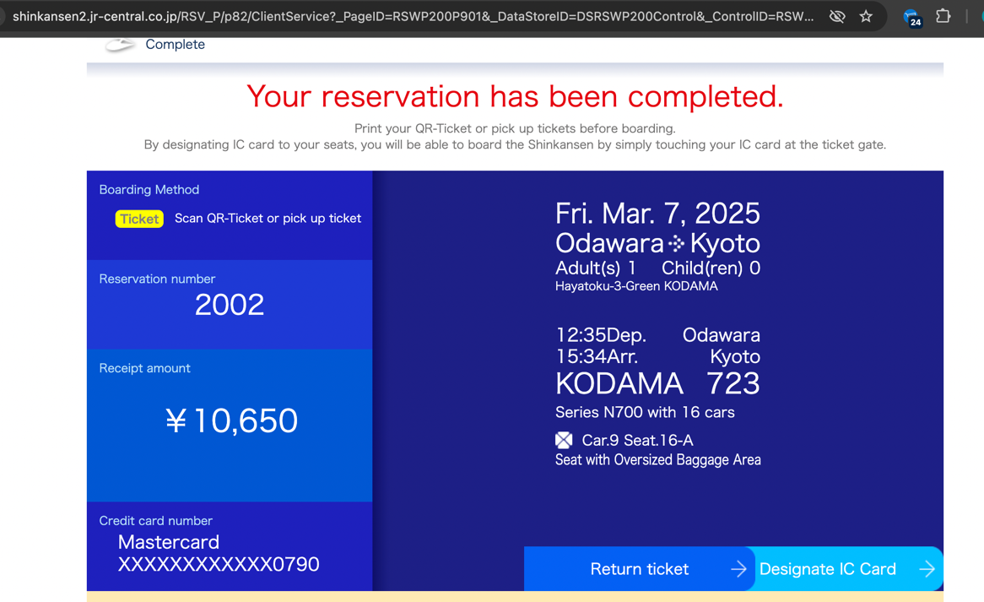

Kyoto, Japan
Friday, March 7th – Tuesday, March 11th

CONTINUED Friday, March 7th Hakone to Kyoto
Head to hotel The Thousand Kyoto (arrive in Kyoto at 3:34pm)
- Very close to Kyoto Station
- KD Notes Afterwards: Great hotel, perfect location next to the main train station – only other area I would consider is Gion

Pokemon Center Kyoto open til 8pm (take pics for TJ)

Dinner at Gion Soy Milk Ramen Uno Yokiko
- Go before 6pm – gets crowded and doesn’t allow reservations
- KD Notes Afterwards: Both times I went there were long lines so I didn’t end up going. They take the last order at 8:30 even though they don’t close until 10pm. Actually didn’t even look that good so happy that I ended up at Moon and Back for soy milk ramen – it was DELICIOUS!

Go to JR Ticket Office at Kyoto Station to buy 10:30am ticket to Tokyo
- NOZOMI10 train from Osaka to Tokyo on 3/13. Green car, seat with oversize luggage, window fuji view

Saturday, March 8th
Workout

Fushimi Inari
- 11 min from hotel on Nara line – looks like it comes fairly frequently and can leave very early (5:30am)

Cycling Tour at 8:30am
- Leave by 7:30am at the latest – 7:15am to stop at a convenience store for onigiri (have some in the JR Saga Arashiyama Station)
- Meet at 8:15am at the North Exit of JR Saga Arashiyama Station
  - coordinates: 35.019135, 135.681285
- 23 min from hotel via San-In Line, which comes every 12 min

Sunday, March 9th
Traditional Tea Ceremony at 10am
- Booked via Viator for $44.60 (already paid): https://www.viator.com/tours/Kyoto/Kyoto-Kiyomizu-Tea-Ceremony-with-Scenic-Garden-View/d332-447988P1
- Can walk there (42 min)

Soccer Game at 2pm
- https://quick.pia.jp/kyotosanga_en/seat?eventCode=2503467&releaseCode=041&performCode=001

Temples

Sound Bath (close to hotel) at 6pm? Still need to set a time, but booked and paid on Viator

Monday, March 10th
Walking Around Town / Shopping
- Glanta for custom ring

Temples

Sake Course & Tasting??
- Either 1-4 or 3-6 https://www.viator.com/tours/Kyoto/Deep-Dive-into-the-Sake-World-in-Kyoto/d332-68250P1

Tuesday, March 11th Kyoto to Osaka
Wrap up anything I didn’t get to in Kyoto & take the train to Osaka in the afternoon

Osaka, Japan
Tuesday, March 11th - Thursday, March 13th

Wednesday, March 12th
Plan
- text

Thursday, March 13th Osaka to Tokyo
Train XX from Osaka to Tokyo at XX:XX (leave early to go back to Tokyo)
- text
Tokyo, Japan
Friday, March 14th

CONTINUED Thursday, March 13th Osaka to Tokyo
Check-in to Hotel The Okura Tokyo

Character Street + Tokyo Station + Pokemon Center / Cafe
- Take pictures for Tyler and get him Japanese Pokemon cards
- Find Bridget a Jellycat purse or something else

Get GF Strawberry Daifuku in Ginza
- Kakuouzan Fruits Daifuku
  - Open 10:30am-8:30pm

Dinner at Kushiage Su again
- Reservation at 7pm

Friday, March 14th Tokyo > Los Angeles > Dallas
Tsukiji Outer Market
- Open 9am-2pm every day

Tomoko recommended this confectionary shop (met at Kushiage Su for lunch)
- https://www.tsuruyayoshinobu.jp/shop/tokyo-mise
- Has a counter you can sit and drink matcha tea while watching them prepare the sweets
  - Some look to be GF – but double check
  - A good place to get gifts

Gluten free churros at Kuroboshi Sweets Asakusa

Go to Senso-ji Temple

Esoragoto Udon & GF tempura in Shibuya!

AA Flight 26 from HND to LAX at 8:25pm
- Get to the airport by 5:30pm
  - Probably leave hotel closer to 4pm to avoid congestion on train OR take a taxi
- Land at LAX at 2:20pm

AA Flight 2024 from LAX to DFW at 4:30pm
- Land at DFW at 9:35pm

